|  |  |
| --- | --- |
| **الاسم**  **The name** | عبدالرحمن نبيل جمعه صادق  Abdelrahman Nabil Gomaa |
| ID | 458 |
| Group | Four |
| Section | 21 |
| B.N | 6 |
| Date | 5/6/2021 |

**Topic : Artificial Intelligence**

**Brief:**

**If we look around us, we discover the importance of artificial intelligence. Artificial intelligence has become necessary and important in our lives and in almost all fields. It has many applications, benefits and advantages, but despite that, it has disadvantages and damages as well. Artificial intelligence is being developed at a very fast rate, and on this web page I try to discuss the extent The importance of this and knowing the history of artificial intelligence and the stages of its development until it reached this amazing form. On this web page I try to mention the many and enormous applications of artificial intelligence.**

**Github-link:** [**https://github.com/abdelrahman-nabil32/-the-project-repository**](https://github.com/abdelrahman-nabil32/-the-project-repository)

**Screenshots:**

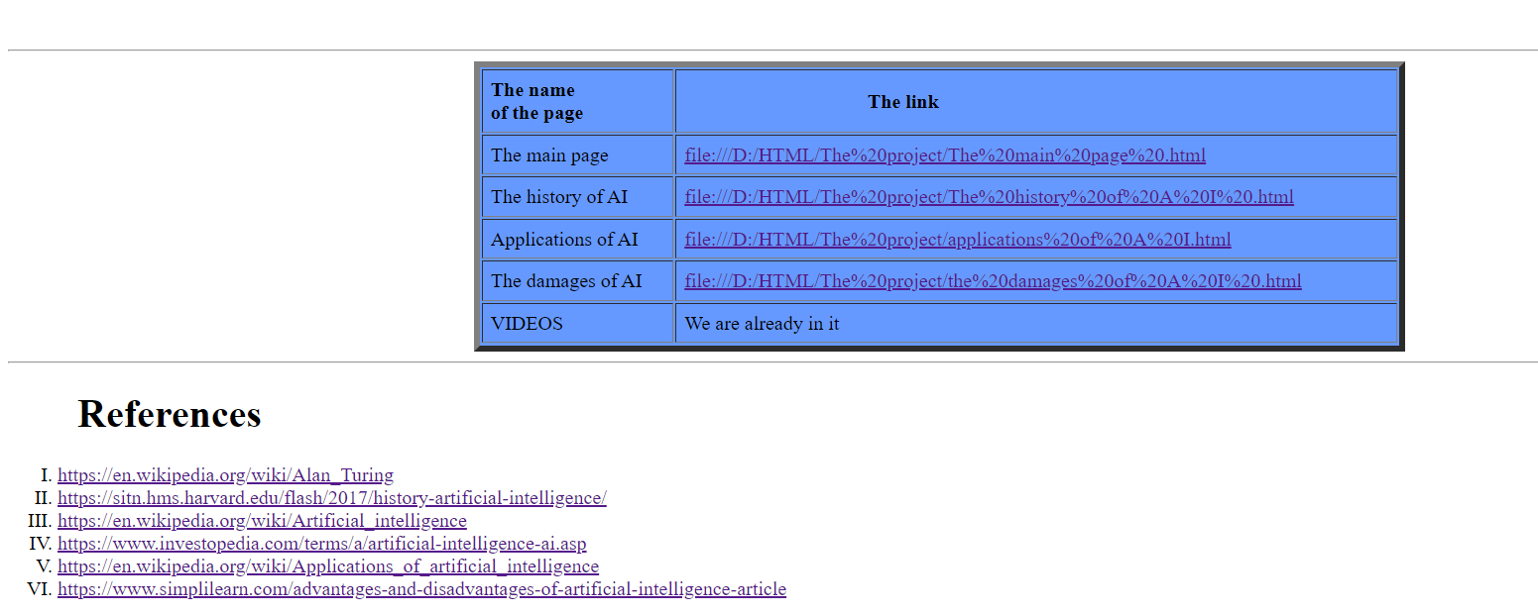

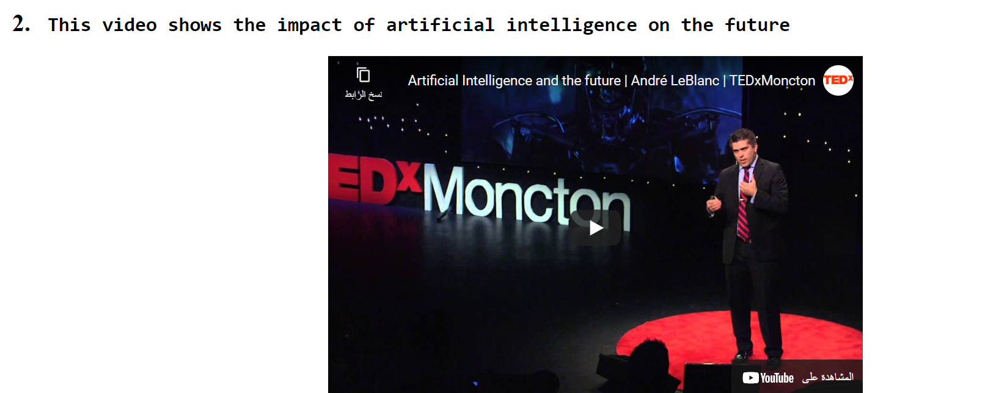

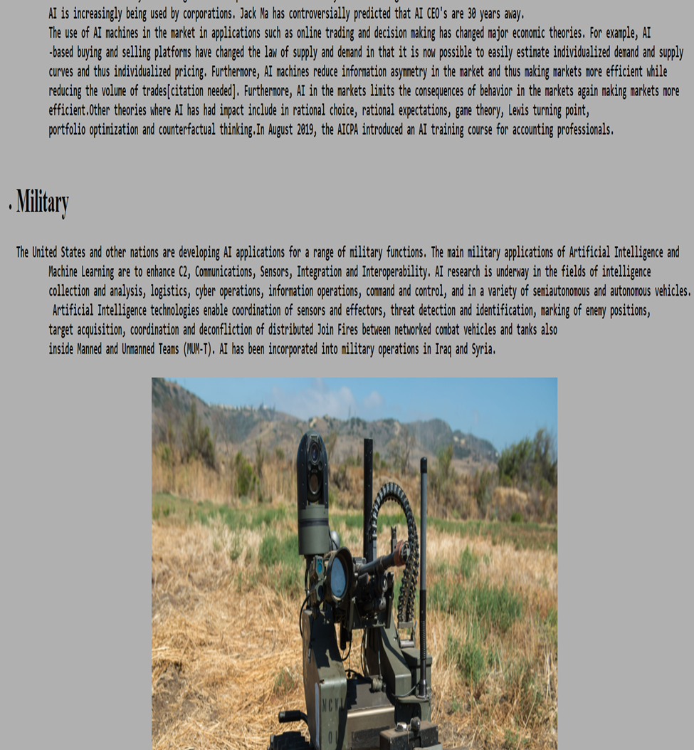

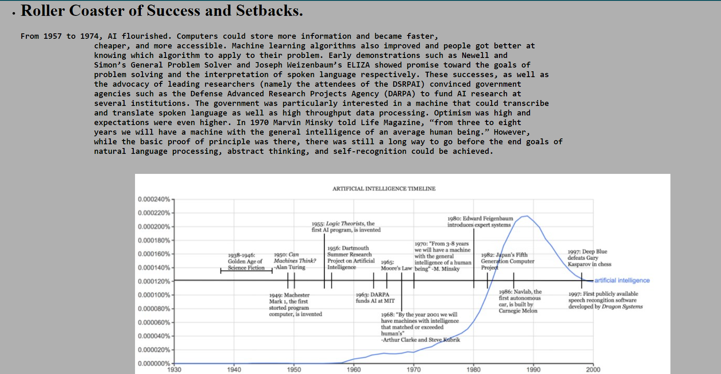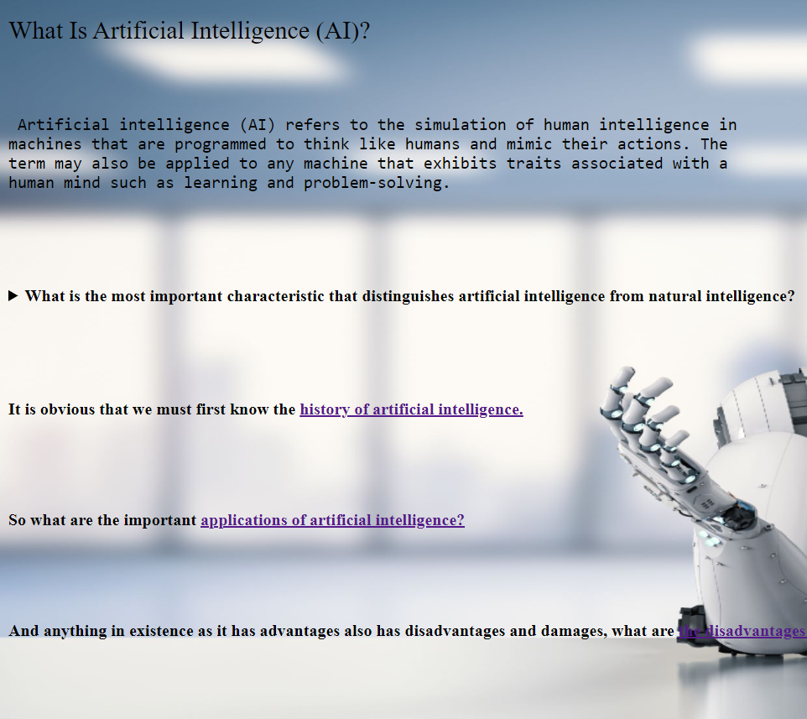

Source code:

